**SEQUENCE CODE:**

import java.util.*;

public class sequenceCode {

Scanner sc = new Scanner(System.in);

static public String trainNumber;

static public String sourceEntered;

static public String destinationEntered;

static public String nameOfPassenger;

static public void login() {

System.out.println("Login Successful");

}

static public void createAccount() {

System.out.println("Entering details......");

System.out.println("Submitting Details....");

System.out.println("Validating details....");

int a = 1;

if (a == 1) {

System.out.println("Details Valid!!");

System.out.println("Account created");

} else {

System.out.println("Details are Invalid!!");

System.out.println("Account not created");

}

}

static public void RequestTicketBookingForm() {

Scanner sc = new Scanner(System.in);

System.out.println("Enter train number");

trainNumber = sc.nextLine();

System.out.println("Enter source");

sourceEntered = sc.nextLine();

System.out.println("Enter destiantion");

destinationEntered = sc.nextLine();

System.out.println("Enter name of the passenger");

nameOfPassenger = sc.nextLine();

}

static public void confirm() {

System.out.println("Train number: " + trainNumber + "\nSource: " + sourceEntered + "\nDestination: "

+ destinationEntered + "\nName of the Passenger: " + nameOfPassenger);

}

static public void payment() {

System.out.println("Payment successful");

}

static public void printTicket() {

System.out.println("Printing initiated\nPrinted started\nPrinting Done...");

}

public static void main(String args[]) {

int ch = 0;

Scanner in = new Scanner(System.in);

do {

System.out.println("\n\nEnter your choice:");

System.out.println(

"0. Login\n1. Create account\n2. Request Ticket booking form\n3. Confirm\n4. Payment\n5. Print Ticket\n6. Exit");

ch = in.nextInt();

switch (ch) {

case 0:

login();

break;

case 1:

createAccount();

break;

case 2:

RequestTicketBookingForm();

break;

case 3:

confirm();

break;

case 4:

payment();

break;

case 5:

printTicket();

break;

}

} while (ch < 6);

}

}

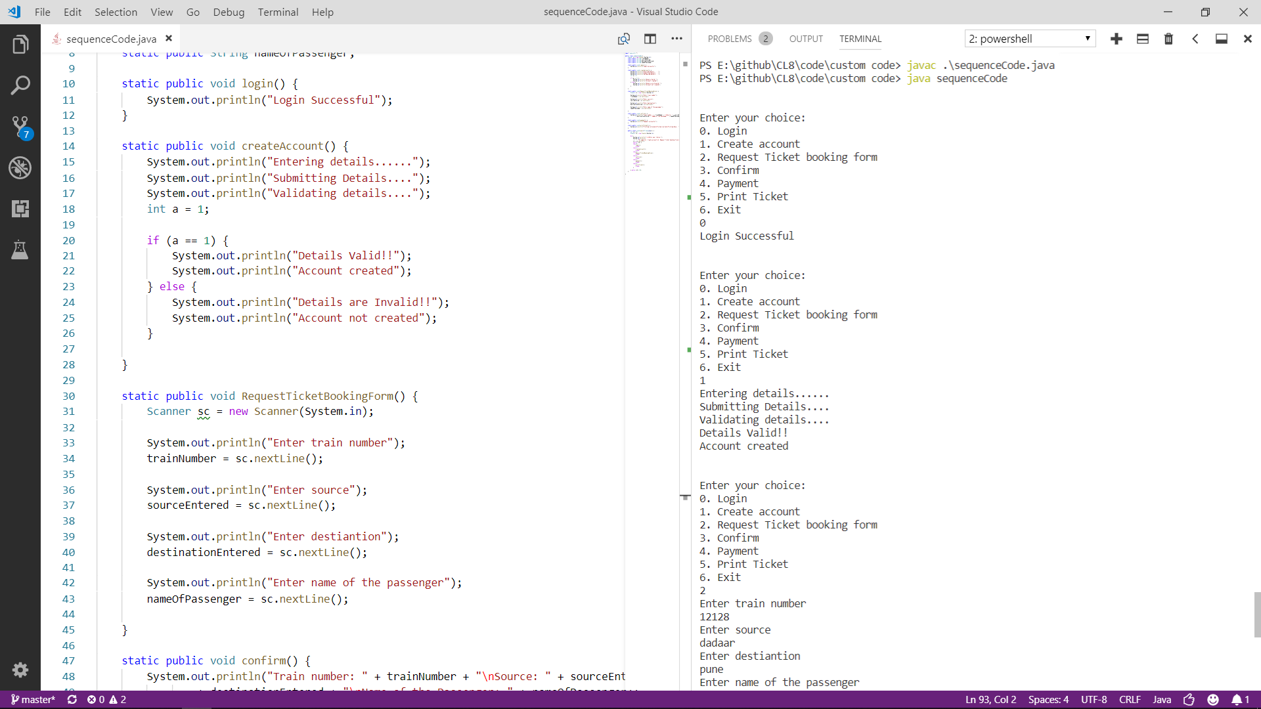

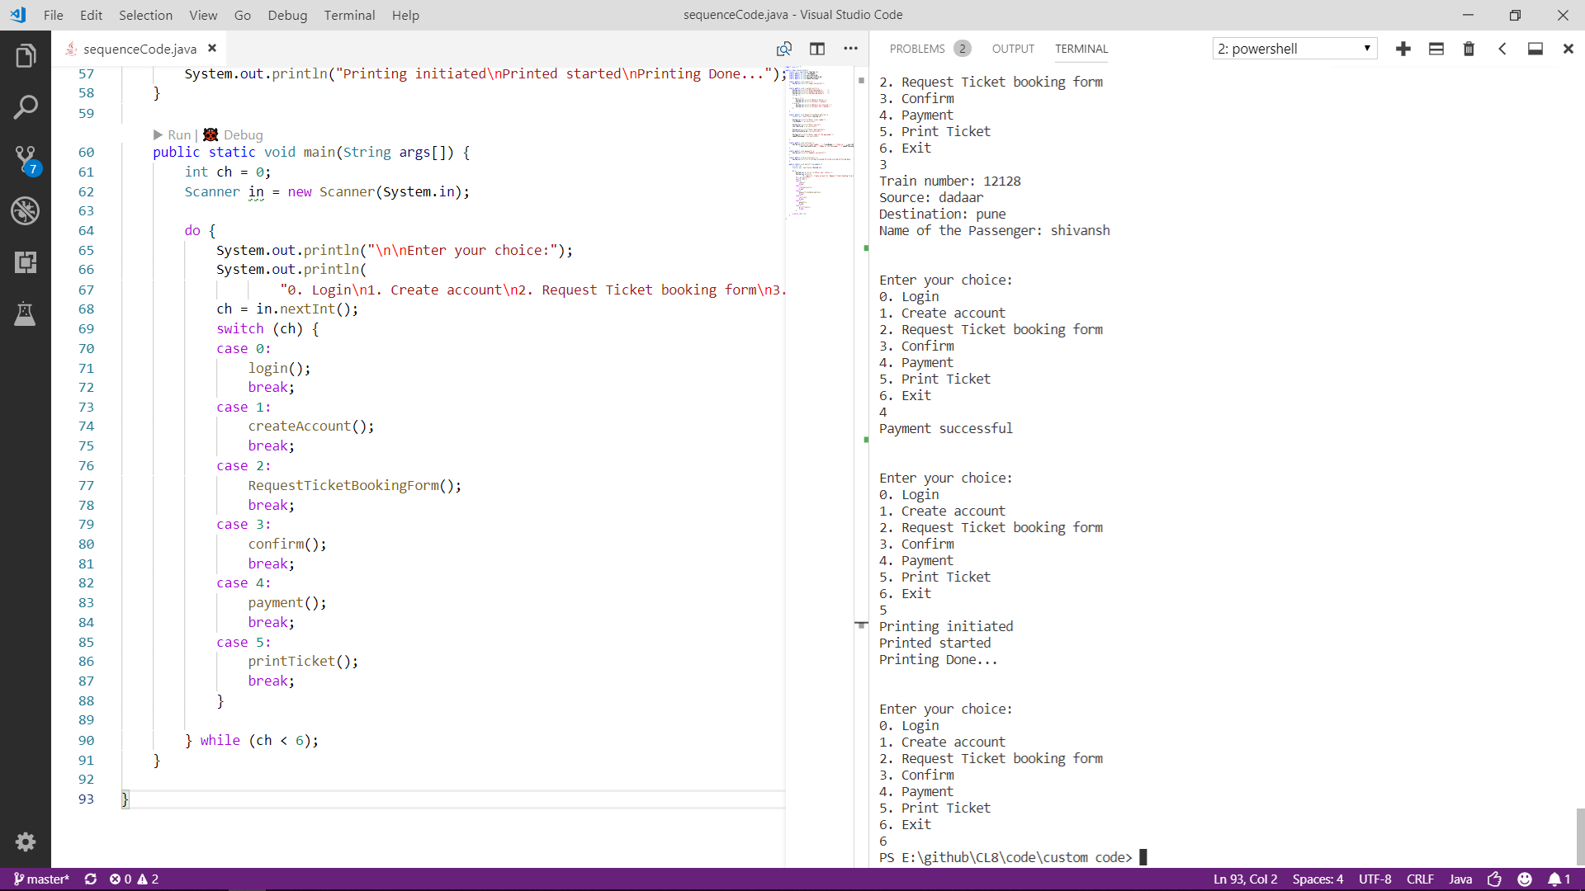

**STATE CODE:**

enum States {

WAITING_FOR_LOGIN, LOGGING_IN, VALIDATING, CHECKING_AVAILIBILTY, BOOKING, PAYING_CHARGES, PRINTING

}

class railway {

private States st = States.WAITING_FOR_LOGIN;

public void login() {

if (this.st.equals(st.WAITING_FOR_LOGIN)) {

System.out.println("Logging in ");

setState(st.LOGGING_IN);

}

}

public void validate(boolean done) {

// validate password

if (this.st.equals(st.LOGGING_IN)) {

if (done) {

System.out.println("Password is correct: Logged into ");

System.out.println("\nDisplaying HomePage\n");

setState(st.CHECKING_AVAILIBILTY);

} else {

System.out.println("\nPassword is incorrect!!\n");

setState(st.WAITING_FOR_LOGIN);

}

} else {

System.out.println(" Server is down!");

}

}

public void checkTrain(boolean done) {

// search resto

if (this.st.equals(st.CHECKING_AVAILIBILTY)) {

if (done) {

System.out.println("Showing train");

setState(st.BOOKING);

System.out.println("Selecting train....");

} else {

System.out.println("no train avaliable!\n");

}

} else {

System.out.println("is not available for search!!");

}

}

public void book(boolean done) {

if (this.st.equals(st.BOOKING)) {

if (done) {

System.out.println("\nBooking train\n");

setState(st.PAYING_CHARGES);

System.out.println("\npaying charges\n");

} else {

System.out.println("\nCannot book train!");

}

} else {

System.out.println("");

}

}

public void printing(boolean done) {

// check stock

if (this.st.equals(st.PRINTING)) {

if (done) {

System.out.println("\nprinting ticket\n");

} else {

System.out.println("\nlooks like payement failed");

}

} else {

System.out.println();

}

}

public void pay(boolean done) {

if (this.st.equals(st.PAYING_CHARGES)) {

if (done) {

System.out.println("\nProcessing Payment!!\n");

setState(st.PRINTING);

System.out.println("\nPayment received!!\n");

} else {

System.out.println("\nPayment not received!!");

}

} else {

System.out.println("is not available for processing payment!!");

}

}

public void setState(States state) {

this.st = state;

}

public static void main(String args[]) {

railway obj1 = new railway();

obj1.login();

obj1.validate(true);

obj1.checkTrain(false);

obj1.book(true);

obj1.pay(true);

obj1.printing(true);

System.out.println("----------------------------------------------------");

railway obj2 = new railway();

obj2.login();

obj2.validate(true);

obj2.checkTrain(false);

obj2.book(true);

obj2.pay(true);

obj2.printing(true);

System.out.println("----------------------------------------------------");

railway obj3 = new railway();

obj3.login();

obj3.validate(true);

obj3.checkTrain(true);

obj3.book(true);

obj3.pay(true);

obj3.printing(true);

}}

